OPERATING SYSTEMS AND SYSTEMS PROGRAMMING
Skill 15-24

2520030159 – hema sri

15.To Parse Combined Redirection, Duplicate File Descriptors, Merge Streams, Verify Ordering, Handle Edge Cases, Test Integrated Outputs.
To Parse Complex Commands, Combine Pipes and Redirections, Resolve Execution Order, Validate Syntax, Generate Execution Plans, Test Scenarios.
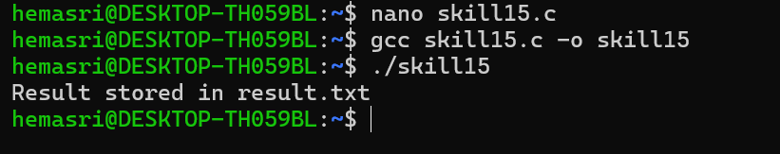
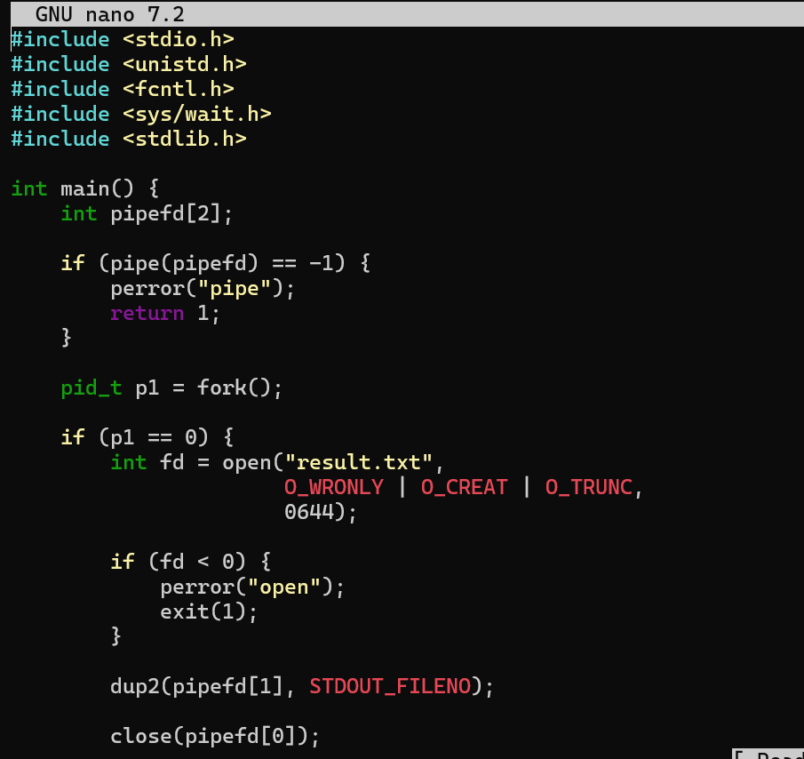
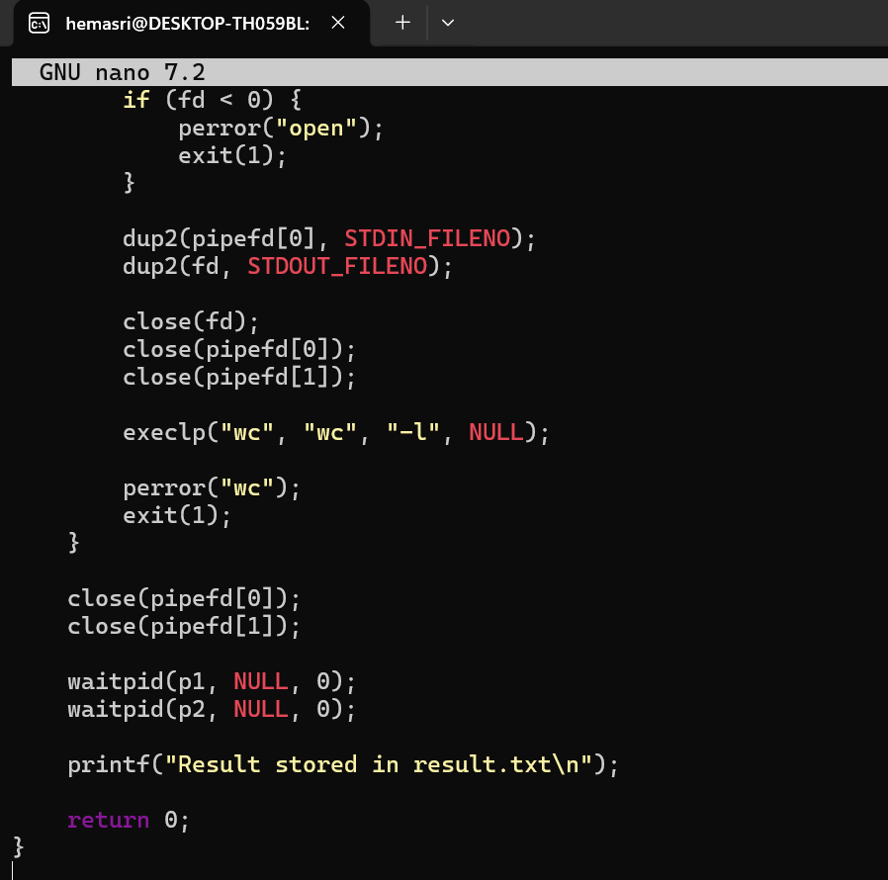
16. To Detect Background Jobs, Launch Non-Blocking Processes, Return Prompt Immediately, Store Job Information, Monitor Execution, Test Background Tasks.
To Create Job Table, Store Process Groups, Track States, Update Status, Remove Completed Jobs, Validate Job Records
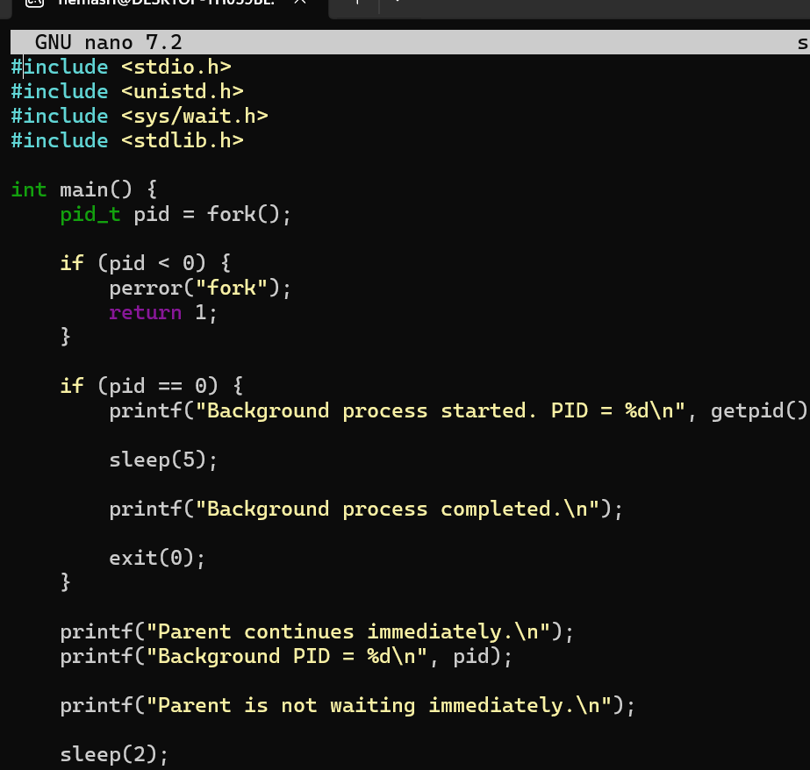
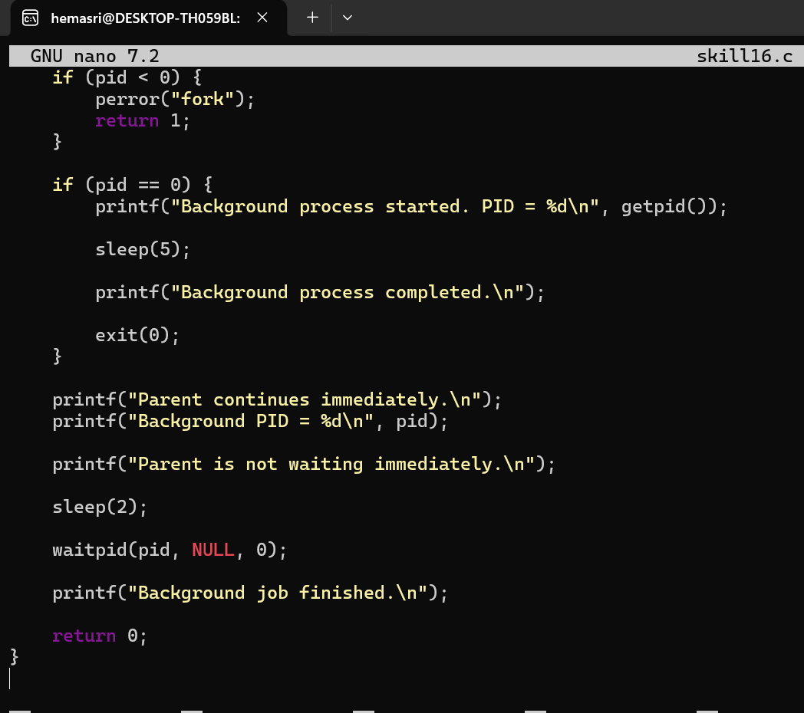

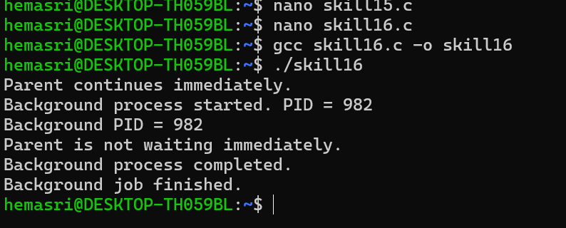
17.

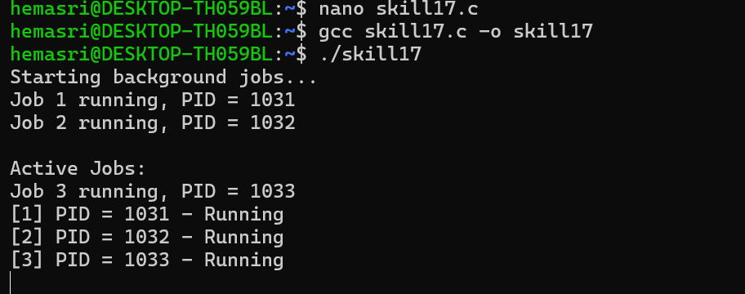
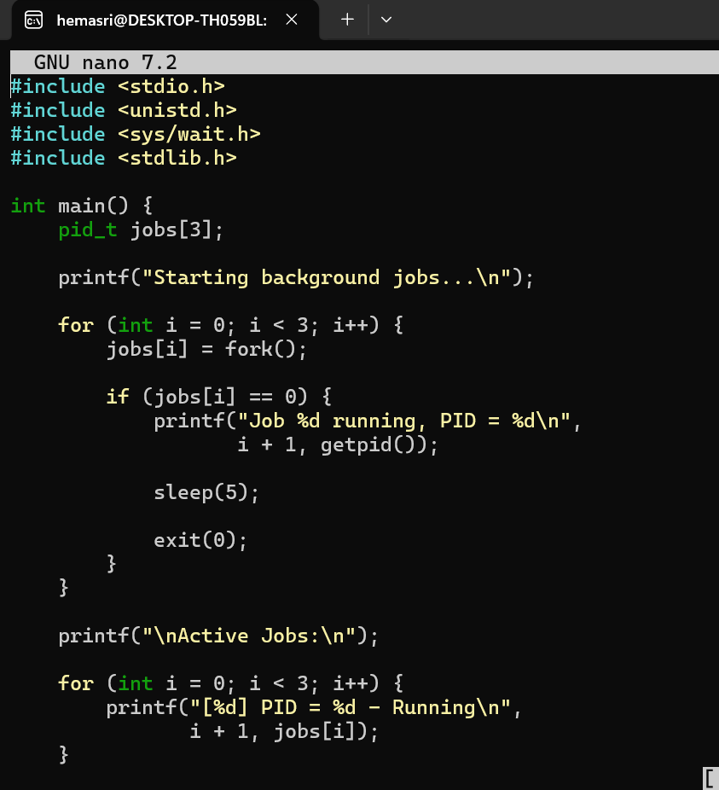
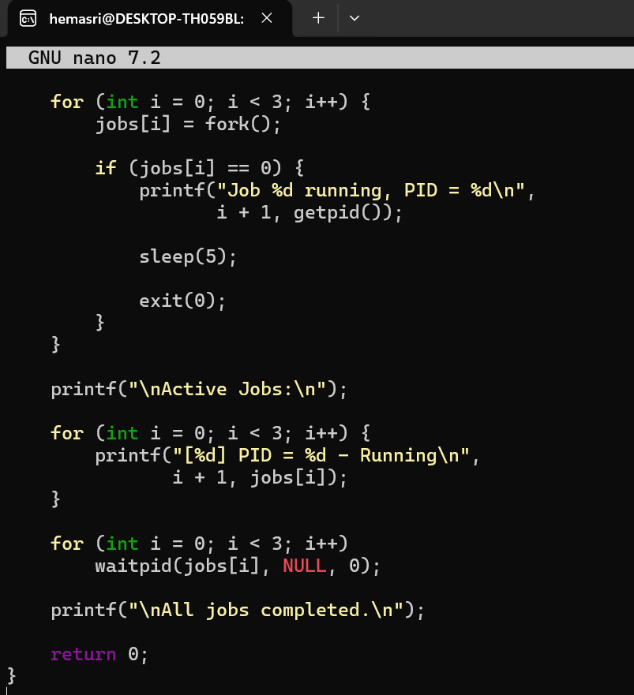

18.
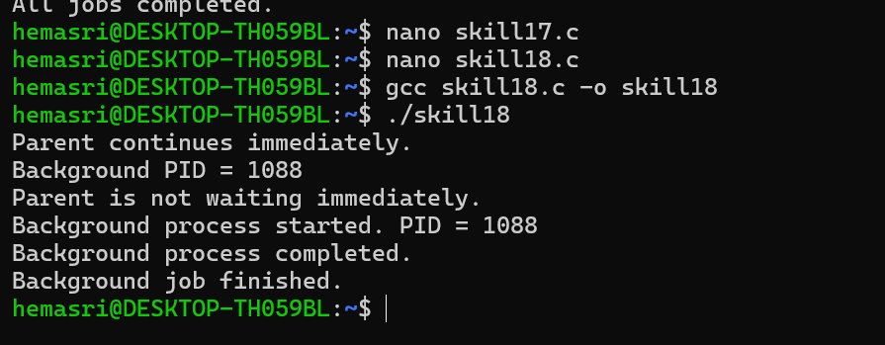
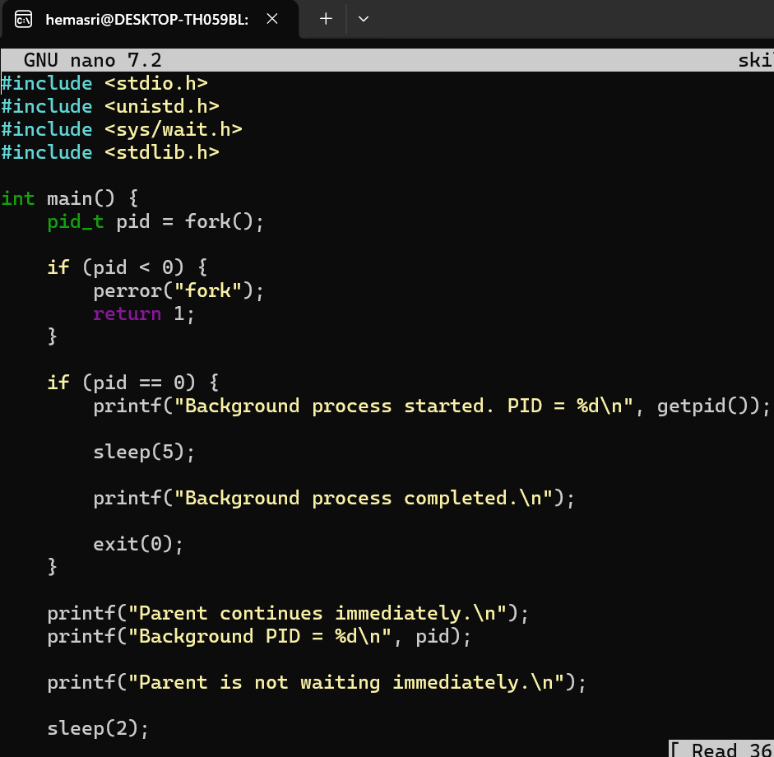
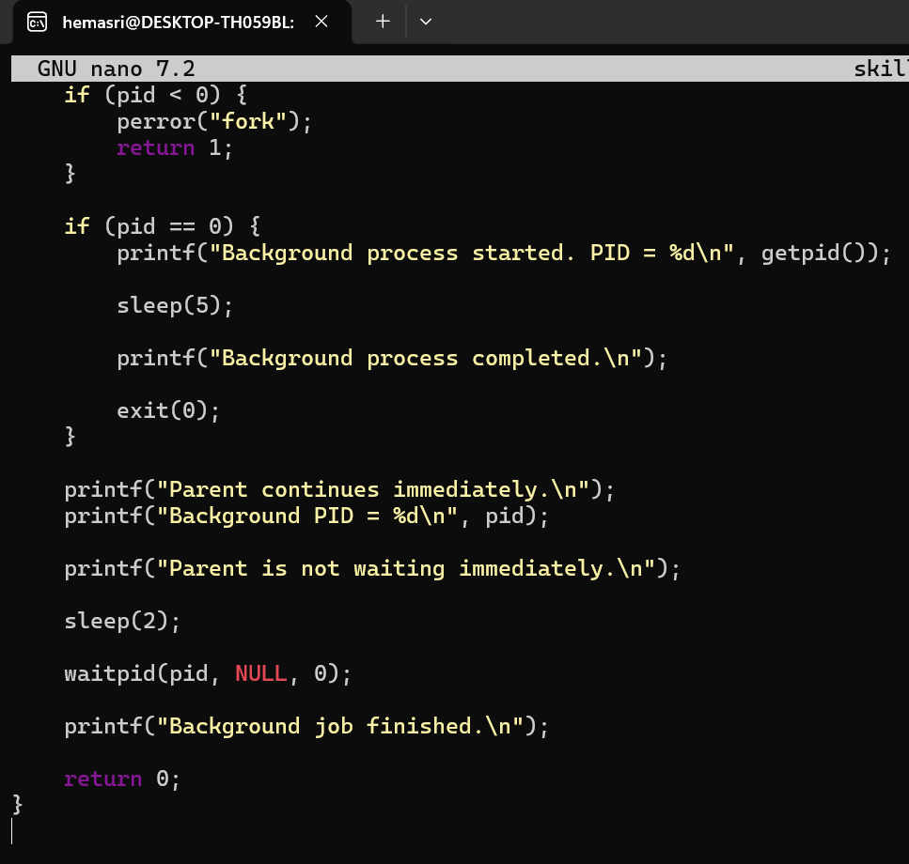
19.
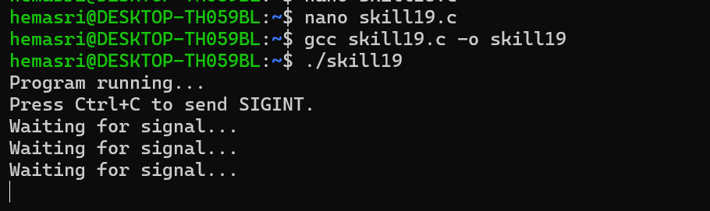
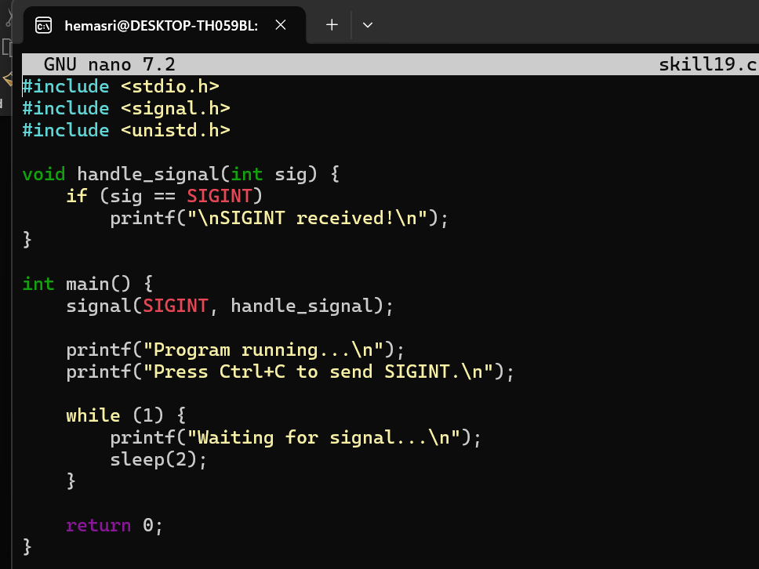
20. 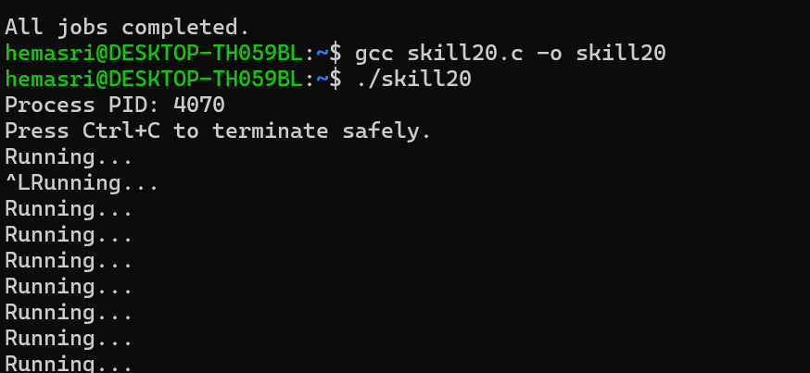
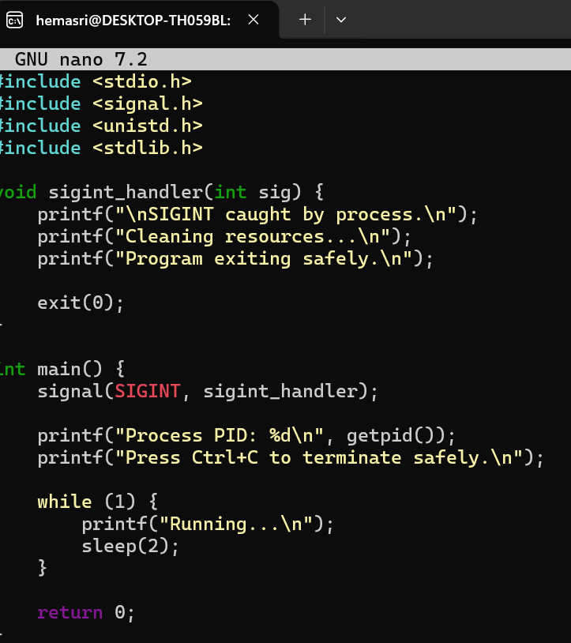
21.
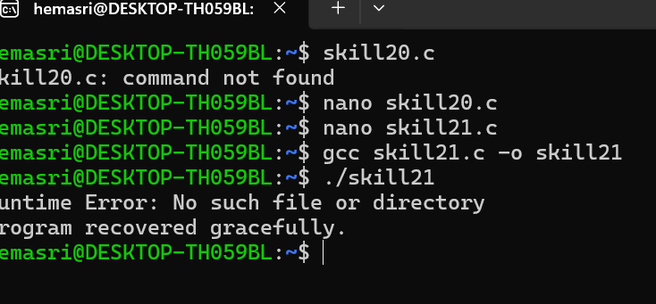
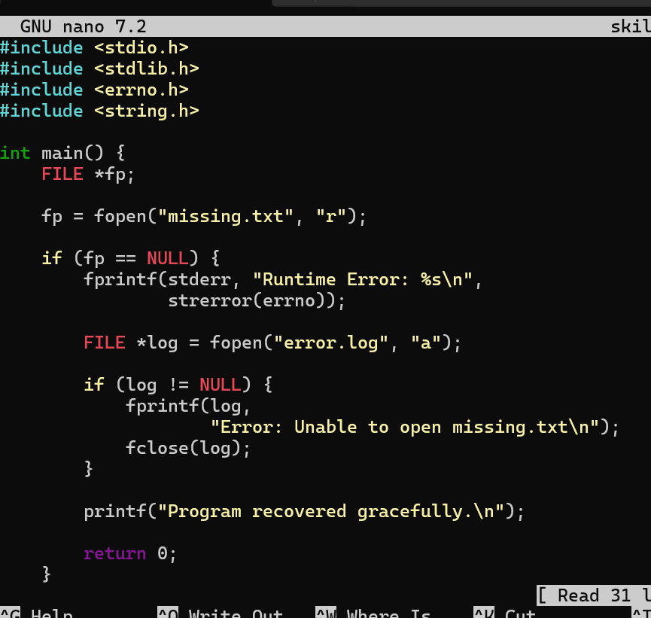

22. . To Run Valgrind, Identify Leaks, Fix Memory Errors, Release Resources, Verify Cleanup, Document Findings.
To Design Test Cases, Create Test Scripts, Automate Execution, Verify Outputs, Compare Results, Generate Reports.
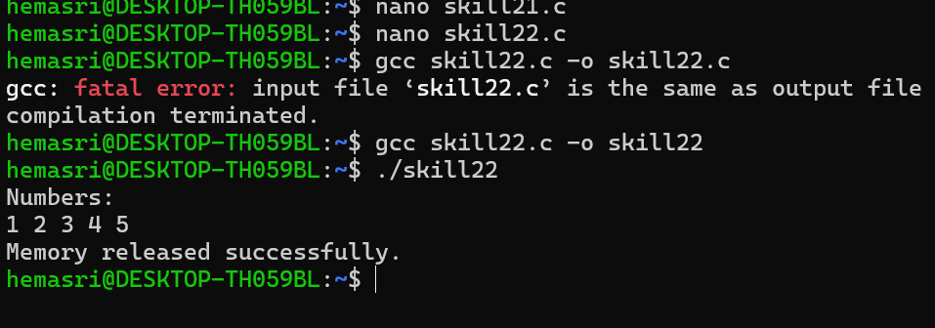
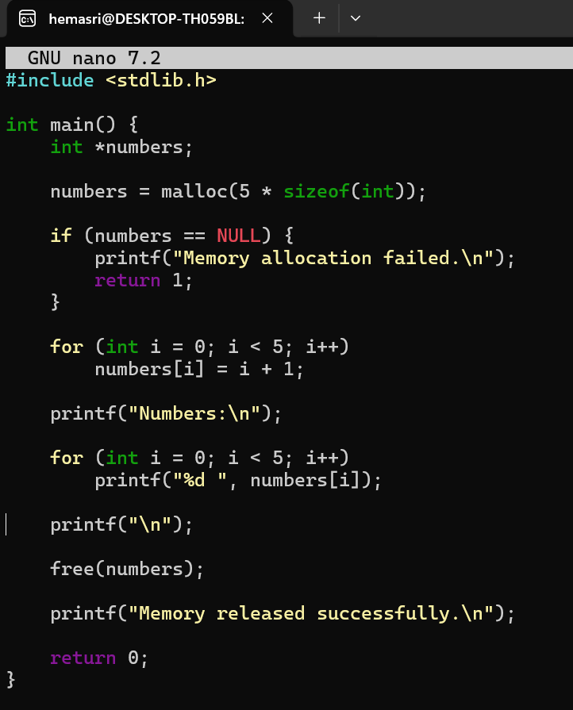

23. To Document Architecture, Create Flow Diagrams, Explain Execution Paths, Describe Syscalls, Record Design Decisions, Review Document
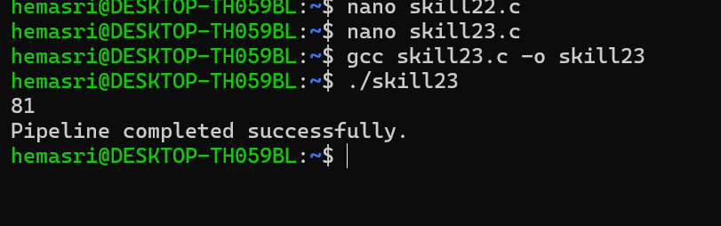
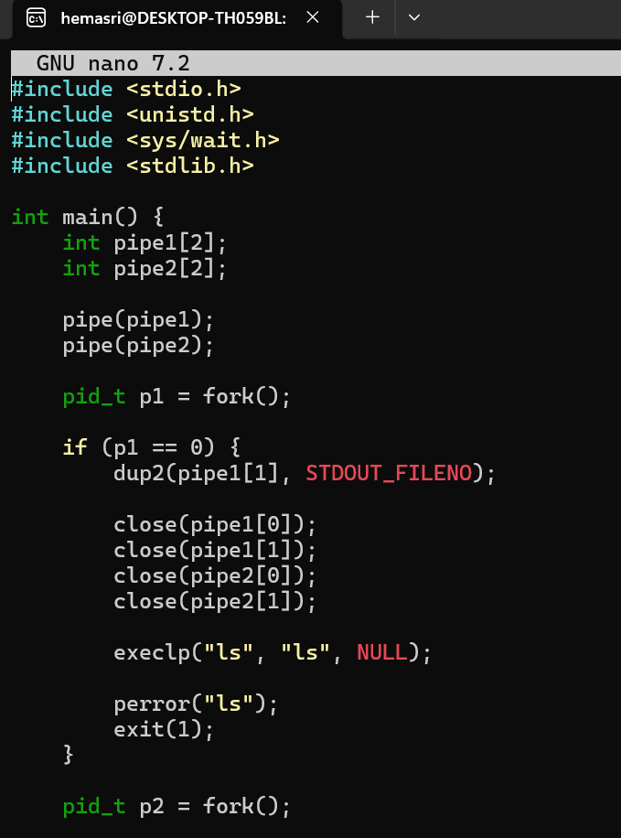

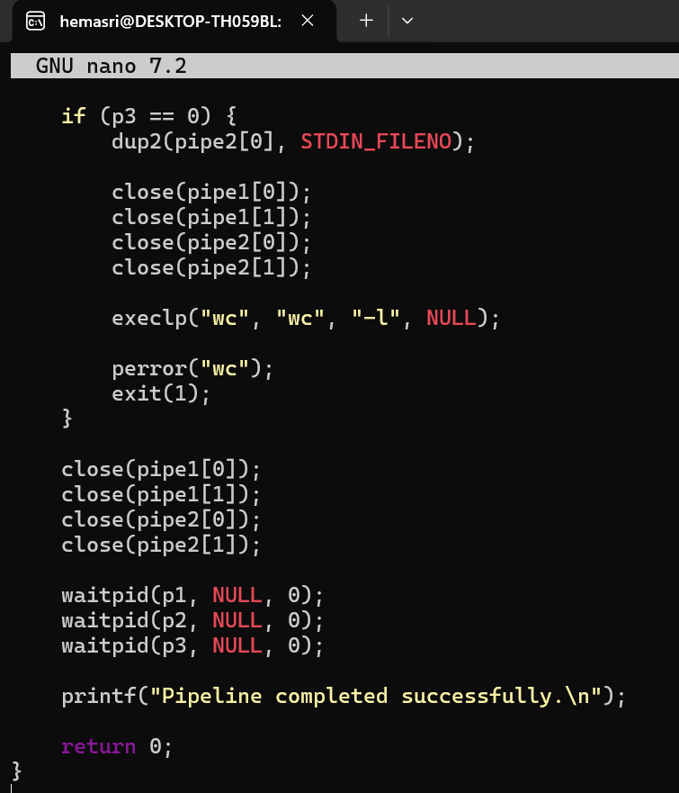
24.
To Organize Source Code, Improve Build Scripts, Add README, Verify Repository Structure, Tag Releases, Validate Deliverables.
To Create Demo Scenarios, Validate Features, Rehearse Presentation, Demonstrate Pipelines, Demonstrate Signals, Final Project Review.
